C:\Users\Administrator\Documents\VALİLİK VE KAYMAKAMLIK E-İMZA\trabzon araklı.tif

C:\Users\caner.demirel\Desktop\Ä°MZA Ã–RNEÄÄ° - Kopya.tif

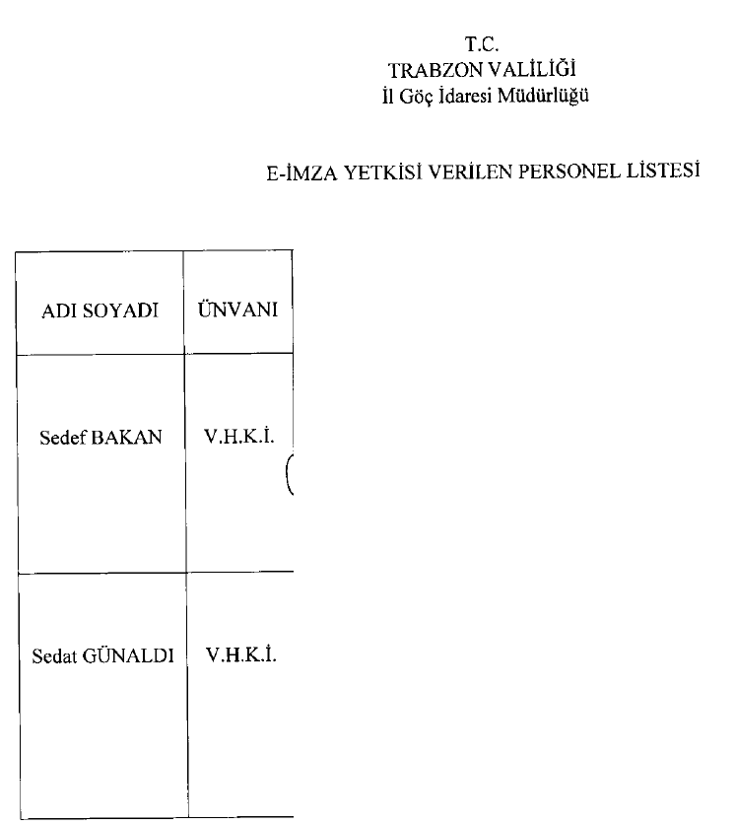

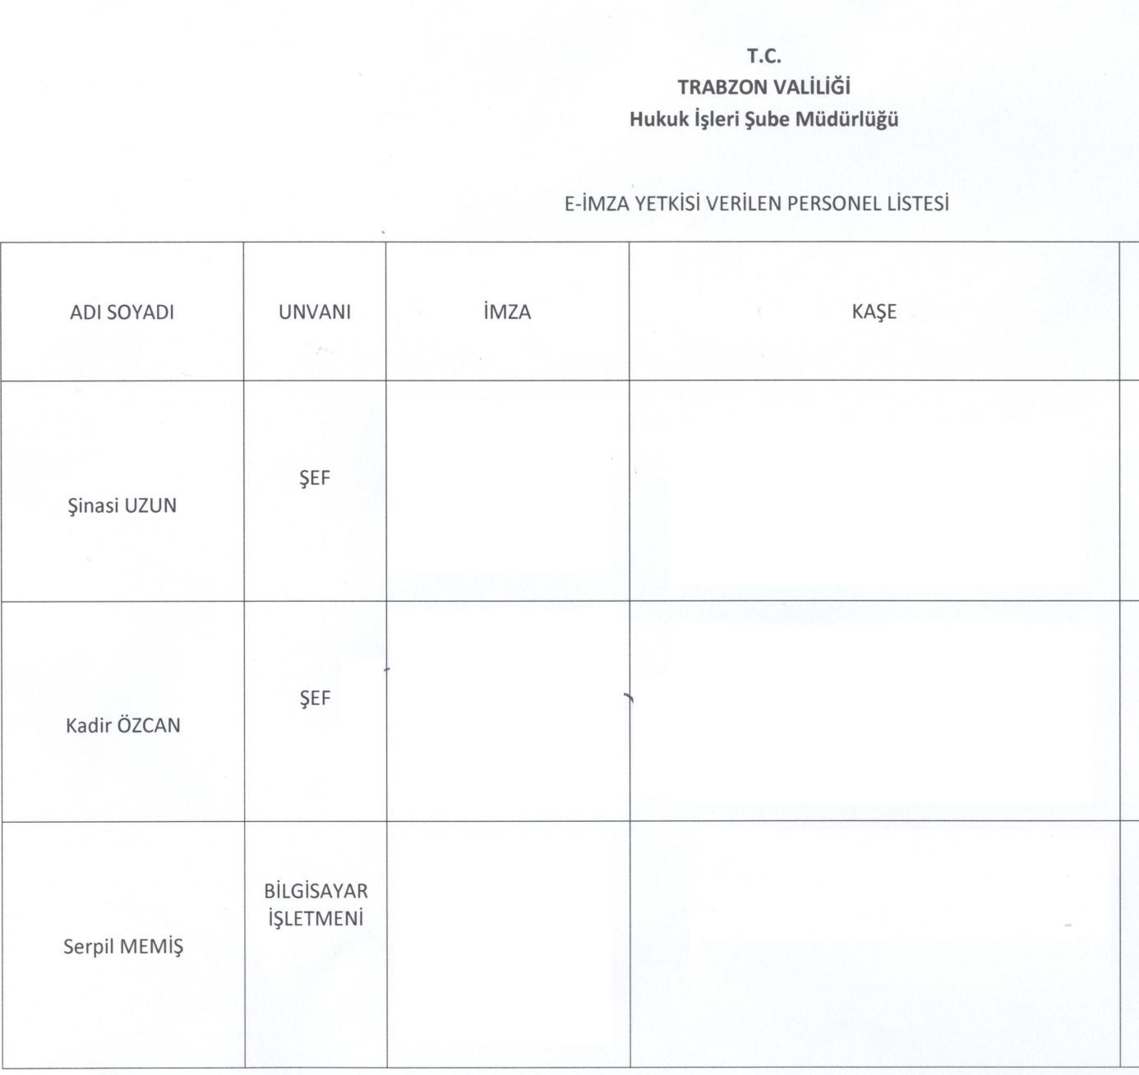

C:\Users\caner.demirel\Desktop\e imza 001.tif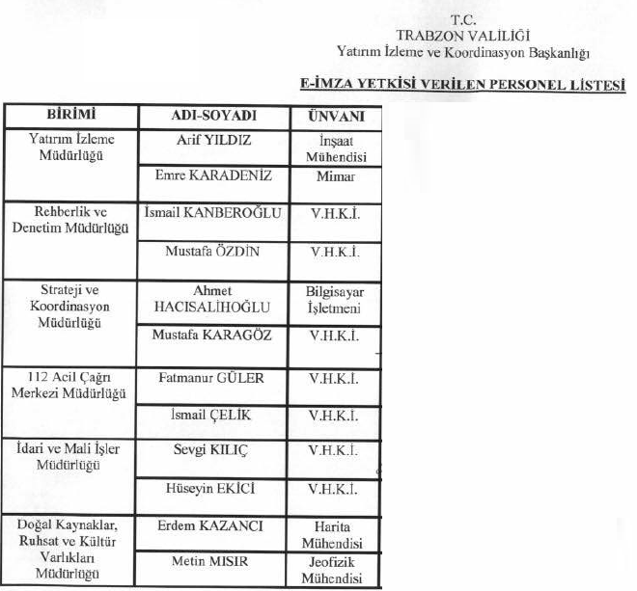

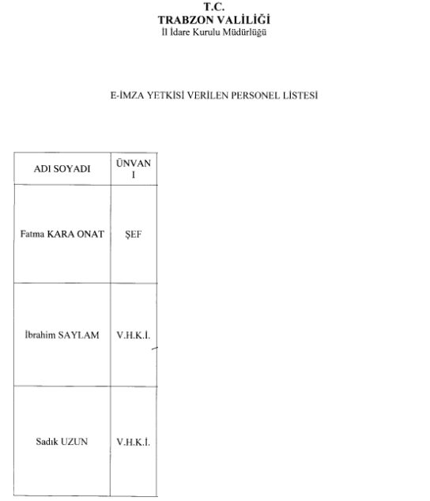

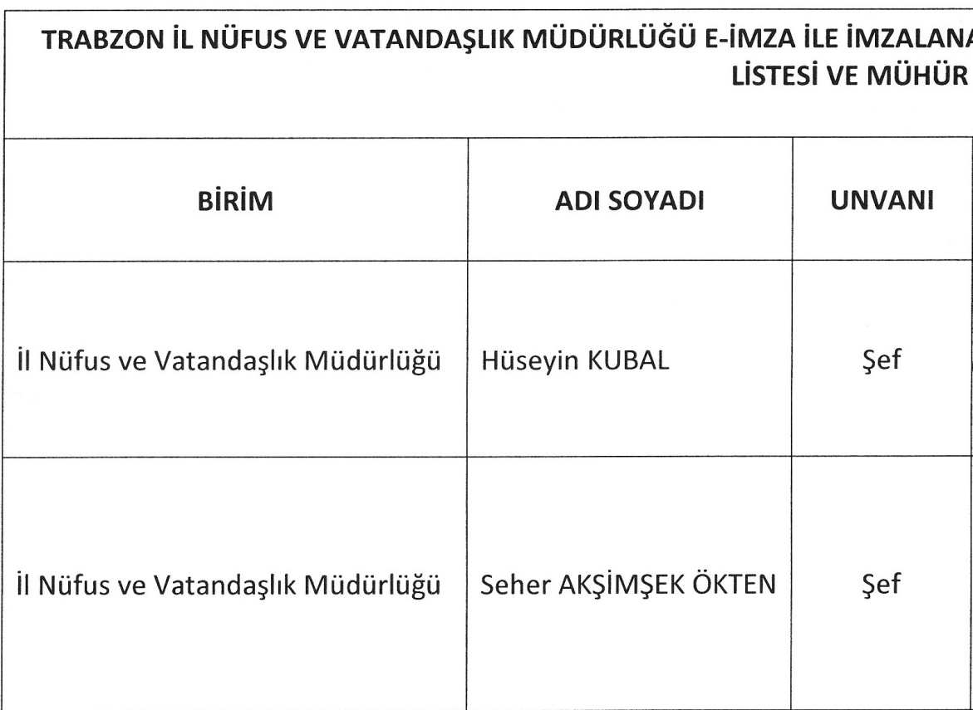

TRABZON VALİLİĞİ

C:\Users\caner.demirel\AppData\Local\Microsoft\Windows\Temporary Internet Files\Content.Word\imza Ã¶rnekleri.tif

