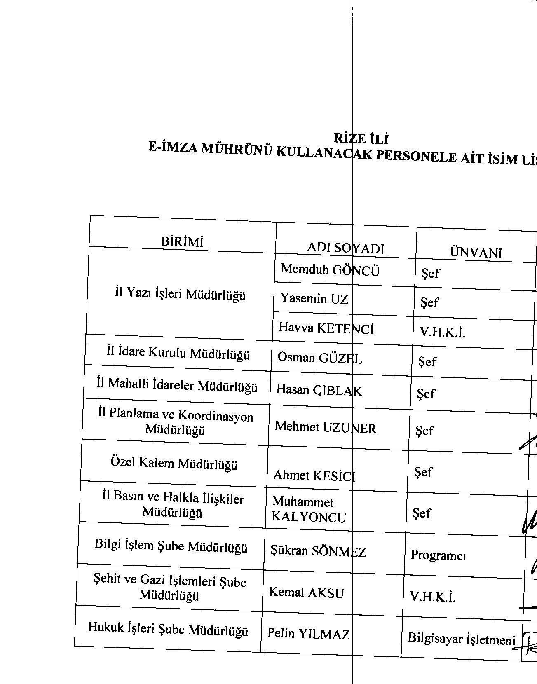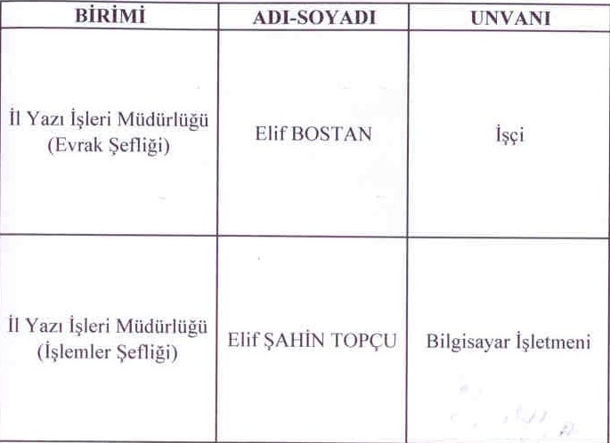

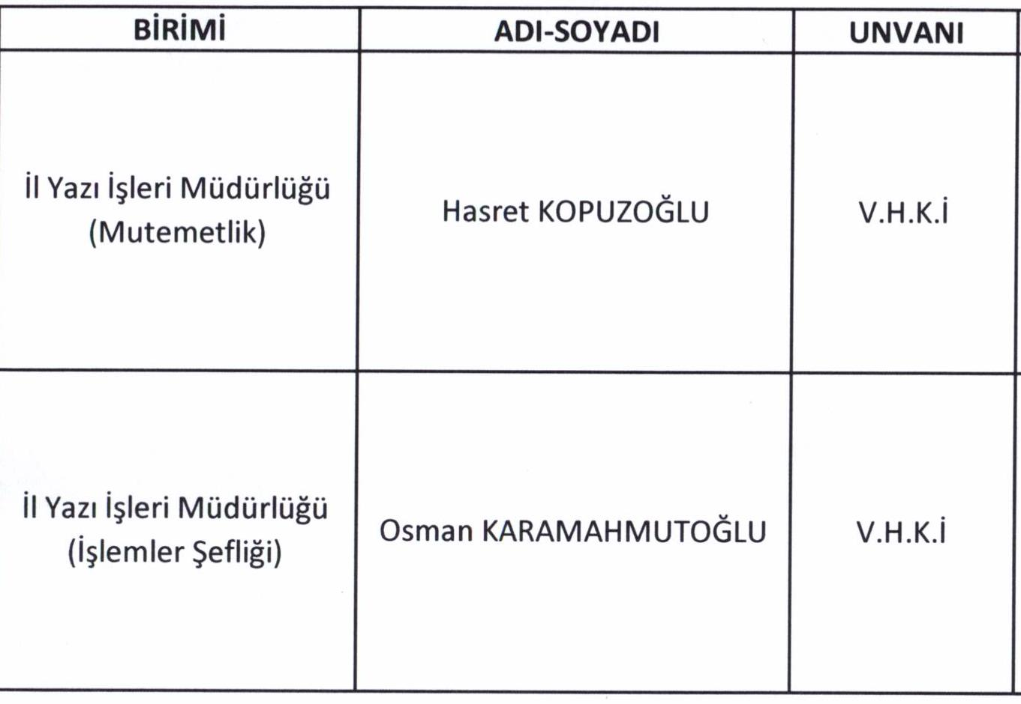

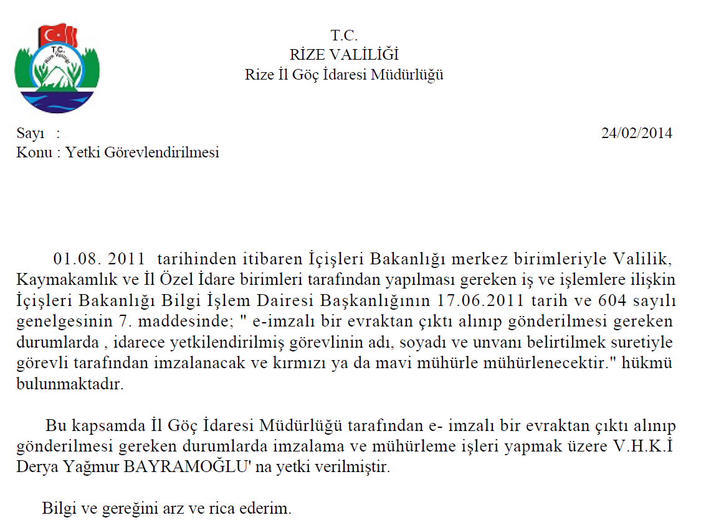

C:\Users\caner.demirel\AppData\Local\Microsoft\Windows\Temporary Internet Files\Content.Word\20160314134701877.tif

**RİZE VALİLİĞİ**

**C:\Users\caner.demirel\Desktop\20160328142549713.tif**

