**NEVŞEHİR VALİLİĞİ**

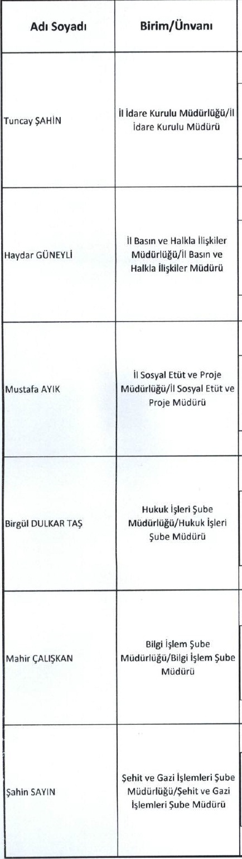

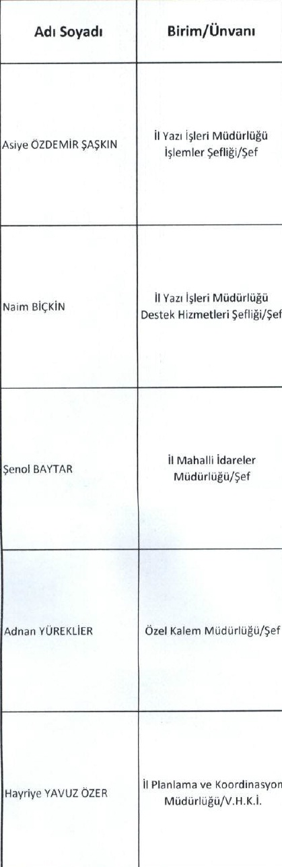



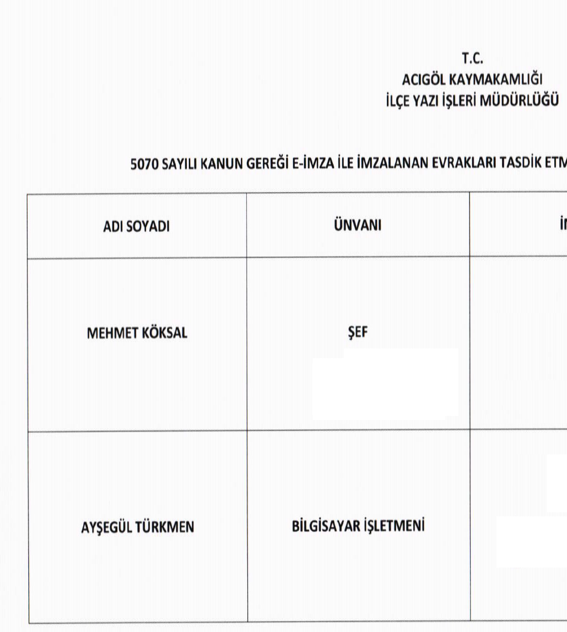

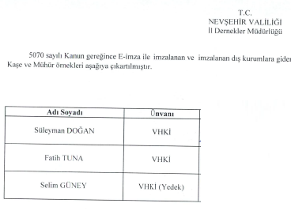

**C:\Users\caner.demirel\Desktop\gÃ¶Ã§idare imza.tif**

**C:\Users\caner.demirel\Desktop\imzamÃ¼hÃ¼r.Tiff**







