C:\Users\caner.demirel\Desktop\imza orneÄŸi.tif

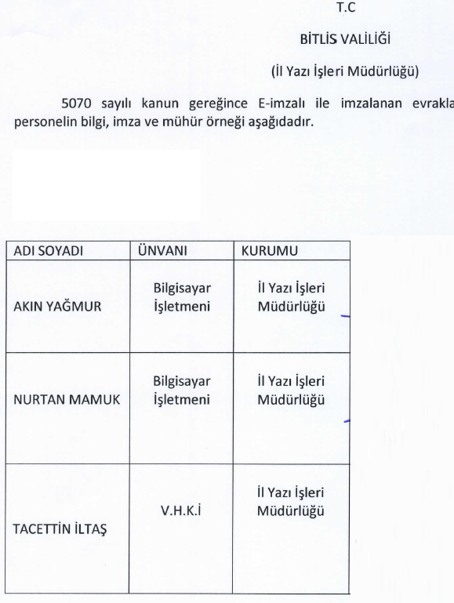

C:\Users\caner.demirel\AppData\Local\Microsoft\Windows\Temporary Internet Files\Content.Word\Ä°mza1005.tif



C:\Users\caner.demirel\Desktop\Ä°l Planama ve Koordinasyon MÃ¼hÃ¼r Ä°mzasÄ± 001.tif





